**University of Michigan – Dearborn**

**Department of Computer and Information Science**

**CIS 150L – Fall 2014**

Lab 6

Srinivas Simhan

10/20/14

**Table of Content**

1. Question 1 3
   1. Screenshot 3
   2. Source Code 3
2. Question 2 4
   1. Screenshot 4
   2. Source Code 4
3. Question 3 6
   1. Screenshot 6
   2. Source Code 6
   3. Diagram 8
4. **Question 1**
   1. **Screenshot**

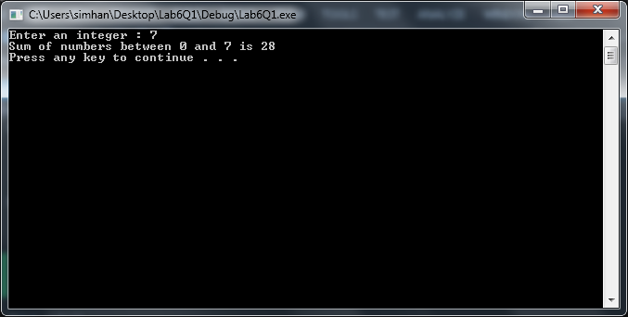

* 1. **Source Code**

//Purpose: Sum of numbers between 0 and number

//Author: Srinivas Simhan

//Creation Date: 10/20/2014

//Last Modification Date: 10/20/2014

#include <iostream>

#include <cmath>

#include <string>

using namespace std;

int addSum(int);

int main()

{

int number, result;

cout << "Enter an integer : ";

cin >> number;

result = addSum(number);

cout << "Sum of numbers between 0 and " << number << " is " << result << endl;

system("pause");

return 0;

}

//Purpose: addSum

//Author: Srinivas Simhan

//Creation Date: 10/20/2014

//Last Modification Date: 10/20/2014

int addSum(int n)

{

int count = 0, sum = 0;

while (count <= n)

{

sum = sum + count;

count++;

}

return sum;

}

1. **Question 2**

**2.1 Screenshot**

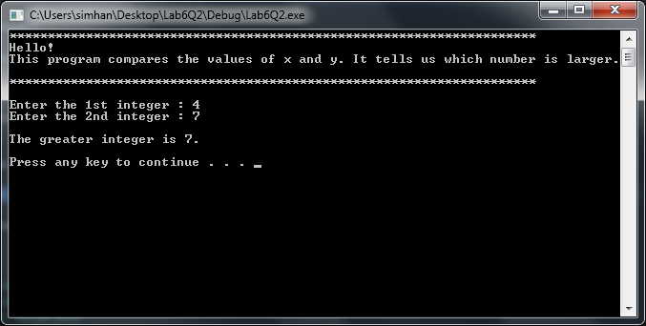

2.2 **Source Code**

//Purpose: What is the Larger Number

//Author: Srinivas Simhan

//Creation Date: 10/20/2014

//Last Modification Date: 10/20/2014

#include <iostream>

#include <cmath>

#include <string>

using namespace std;

int max(int, int);

void instructions();

int main()

{

int x, y, Answer;

instructions();

cout << "Enter the 1st integer : ";

cin >> x;

cout << "Enter the 2nd integer : ";

cin >> y;

Answer = max (x, y);

cout << endl << "The greater integer is " << Answer << "." << endl << endl;

system("pause");

return 0;

}

//Purpose: Return Max Number

//Author: Srinivas Simhan

//Creation Date: 10/20/2014

//Last Modification Date: 10/20/2014

int max(int x, int y)

{

if (x >= y)

return x;

else return y;

}

//Purpose: Provide Instructions

//Author: Srinivas Simhan

//Creation Date: 10/20/2014

//Last Modification Date: 10/20/2014

void instructions()

{

cout << "*********************************************************************" << endl

<< "Hello!" << endl

<< "This program compares the values of x and y. It tells us which number is larger." << endl

<< "*********************************************************************" << endl << endl;

}

1. **Question 3**
   1. **Screenshot**

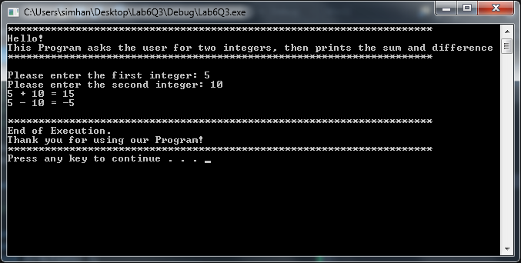

* 1. **Source Code**

// Purpose: Prints the Sum and Difference of Two Integers

// Author: Srinivas Simhan

// Creation Date: 10/20/2014

// Last Modification Date: 10/20/2014

#include <iostream>

#include <string>

using namespace std;

int addition(int, int);

int subtraction(int, int);

void directions( );

void printResult(int, int, int, string);

void endingMessage();

int main()

{

int x, y, r;

directions();

cout << "Please enter the first integer: ";

cin >> x;

cout << "Please enter the second integer: ";

cin >> y;

r = addition(x, y);

printResult(x, y, r, "+");

r = subtraction(x, y);

printResult(x, y, r, "-");

endingMessage();

system("pause");

return 0;

}

// Purpose: int addition

// Author: Srinivas Simhan

// Creation Date: 10/20/2014

// Last Modification Date: 10/20/2014

int addition(int a, int b)

{

int r;

r = a + b;

return (r);

}

// Purpose: int Subtraction

// Author: Srinivas Simhan

// Creation Date: 10/20/2014

// Last Modification Date: 10/20/2014

int subtraction(int a, int b)

{

int r;

r = a - b;

return (r);

}

// Purpose: Directions

// Author: Srinivas Simhan

// Creation Date: 10/20/2014

// Last Modification Date: 10/20/2014

void directions()

{

cout << "*********************************************************************" << endl

<< "Hello!" << endl

<< "This Program asks the user for two integers, then prints the sum and difference" << endl

<< "*********************************************************************" << endl << endl;

}

// Purpose: printResult

// Author: Srinivas Simhan

// Creation Date: 10/20/2014

// Last Modification Date: 10/20/2014

void printResult(int a, int b, int result, string operation)

{

cout << a << " " << operation << " " << b << " = " << result << endl;

}

// Purpose: ending Message

// Author: Srinivas Simhan

// Creation Date: 10/20/2014

// Last Modification Date: 10/20/2014

void endingMessage()

{

cout << endl

<< "*********************************************************************" << endl

<< "End of Execution." << endl

<< "Thank you for using our Program!" << endl

<< "*********************************************************************" << endl;

}

* 1. **Diagram**

